# Access Review – Certification Procedure for Account Approvers

**Purpose:**  Account Approvers must use the OIA Access Certification Tool to certify that the identified users are authorized to have access to the assigned assets

**Scope:**  Users of Critical, Sox, FISMA, and Internet Facing applications.

**Procedure:**

You will receive an email from the OIA Access Certification Tool.



Click the link provided in your email to open the Access Certifier Tool.

**Locate your Certifications within the tool**

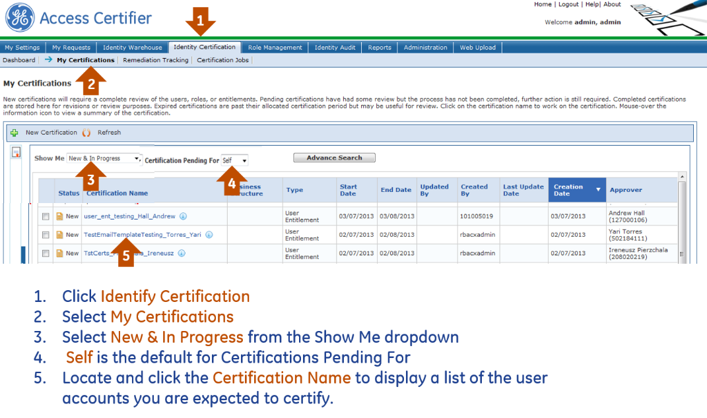

**Certify or Revoke each account**

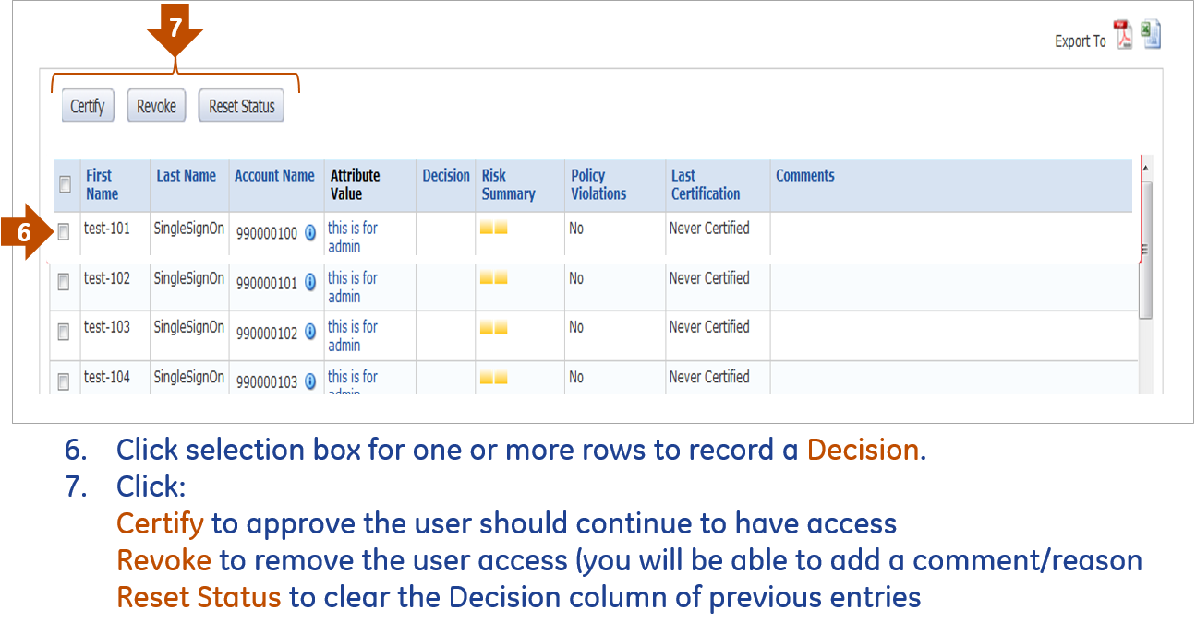

**Monitor the Status of your Certifications**

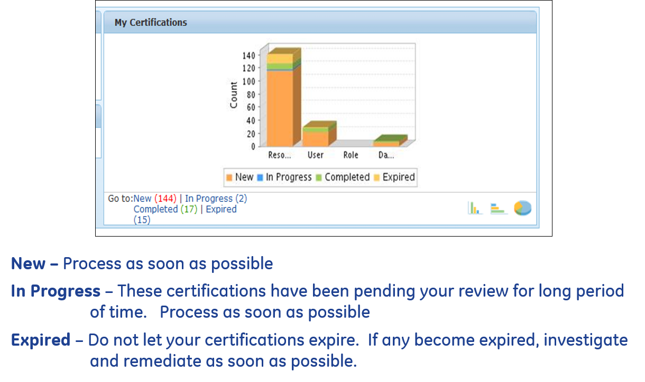

**\*\*Accounts that you do not certify by the deadline are disabled \*\***

For additional Access Certifier Tool instructions, consult the [ACT User Guide](https://ge.app.box.com/s/rueu2i2xf9y9lx6hpu11kb3g7uekcjhv).